**Cognizant Digital Nurture 4.0**

***WEEK - 7 Module 10 Single_Page_Application_framework_React_Task_Solutions***

**9. ReactJS-HOL (MANDATORY)**

Create a React Application named “cricketapp” with the following components:

1. Create the React Application

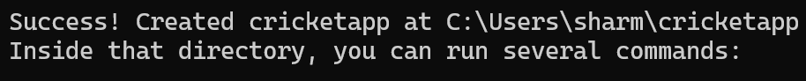

1. Create the Players Data

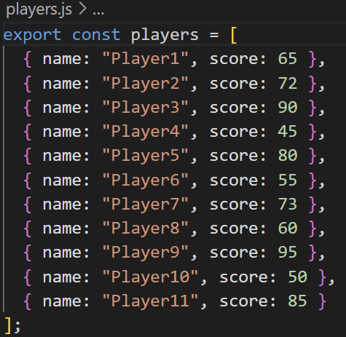

1. Create the ListofPlayers Component

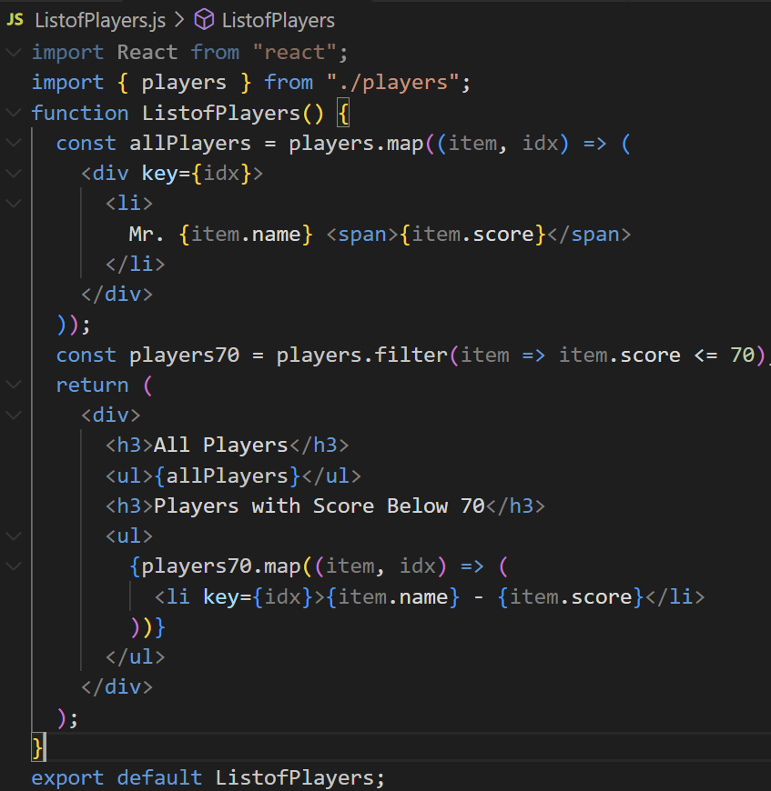

1. Create the IndianPlayers Component

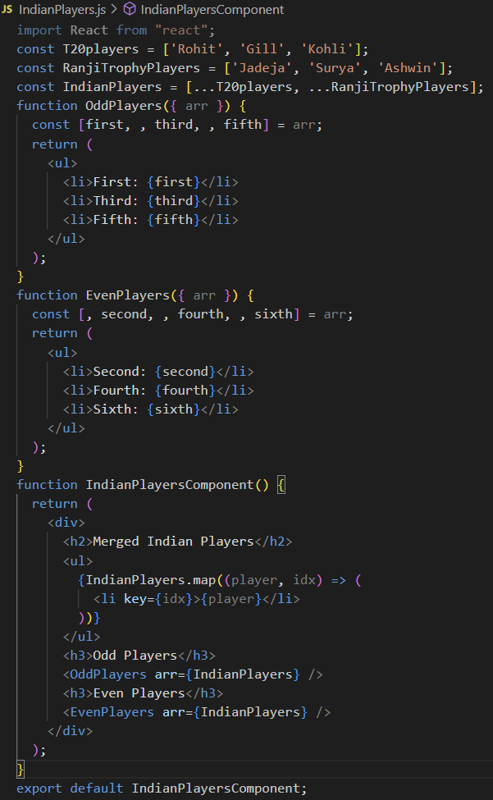

1. Control Component Display with a Flag

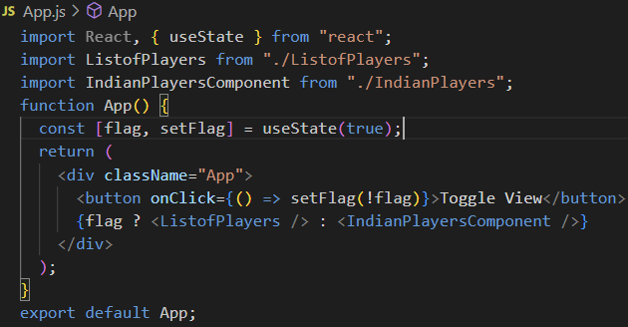

1. Run Your Application

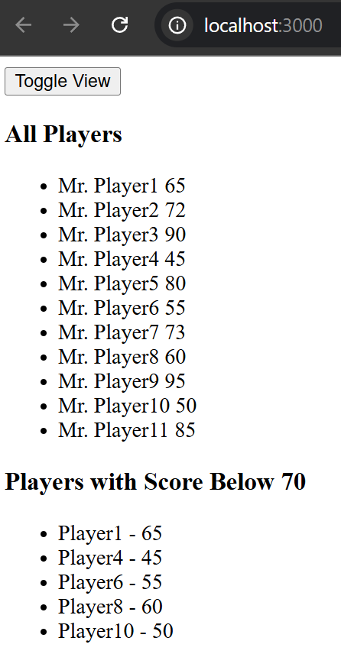

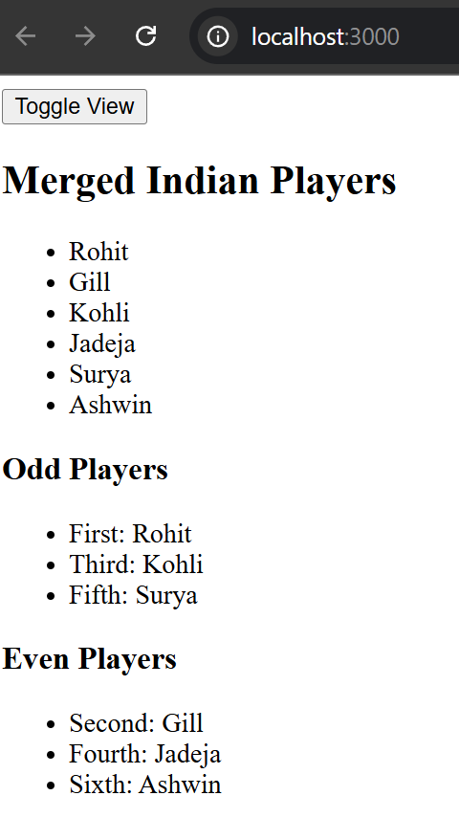

**10. ReactJS-HOL (MANDATORY)**

Create a React Application named “officespacerentalapp” which uses React JSX to create elements, attributes and renders DOM to display the page.

Create the React App



Edit App.js

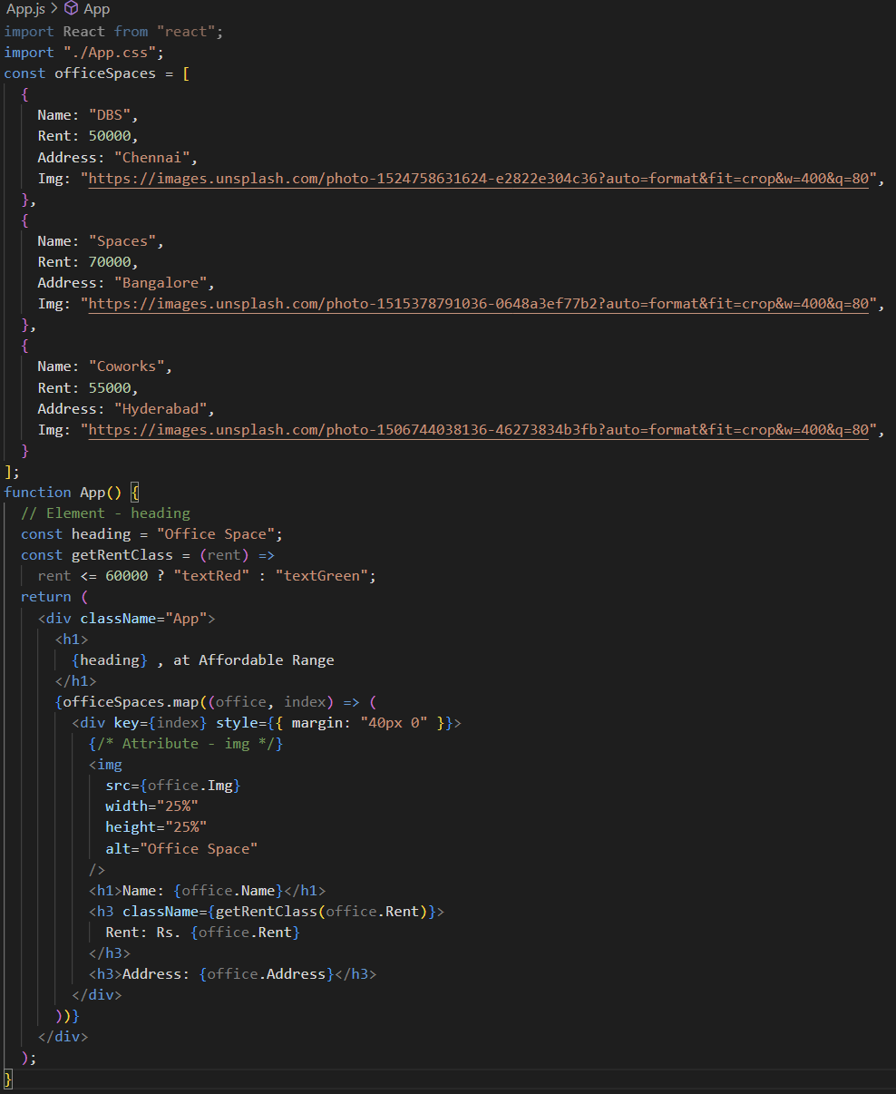

Add CSS (App.css)

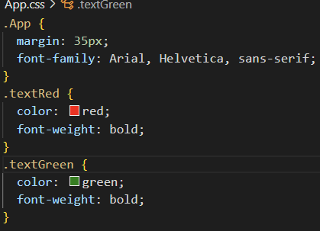

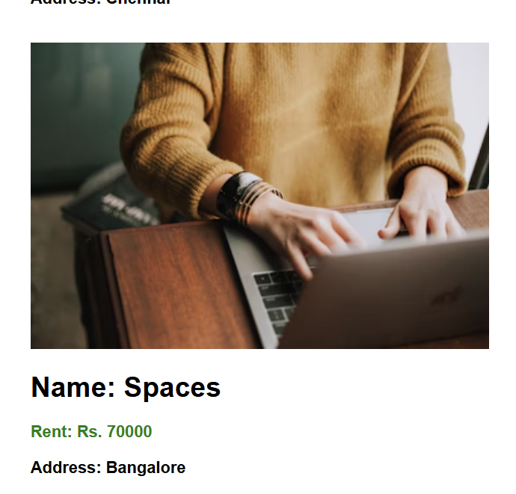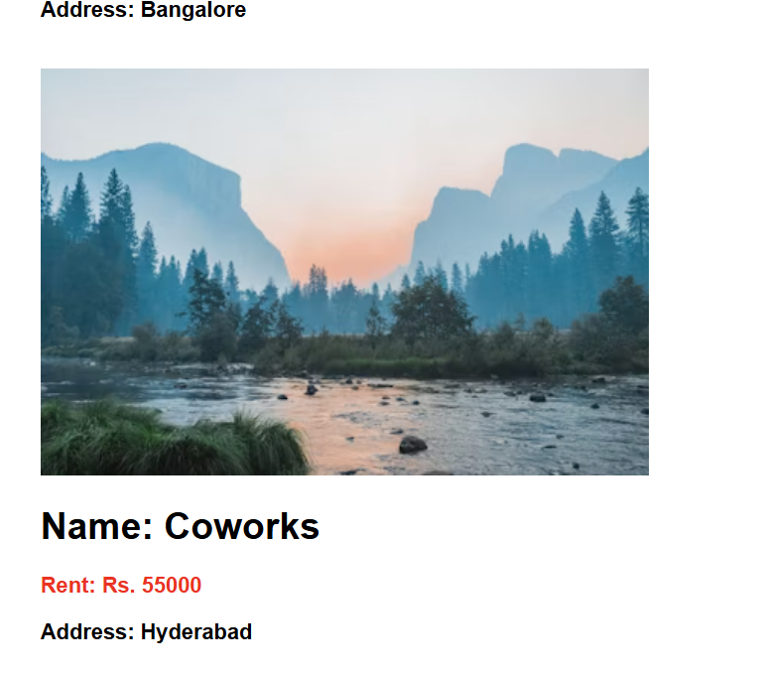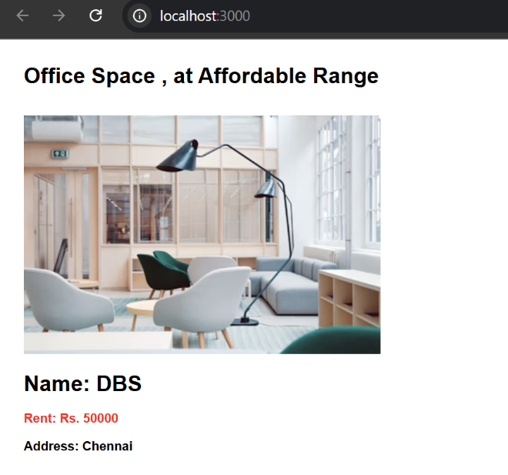Run the Application  
>> npm start

**11. ReactJS-HOL (MANDATORY)**

**Create a React Application “eventexamplesapp” to handle various events of the form elements in HTML.**

1. Create the app:

>>npx create-react-app eventexamplesapp

>>cd eventexamplesapp



1. 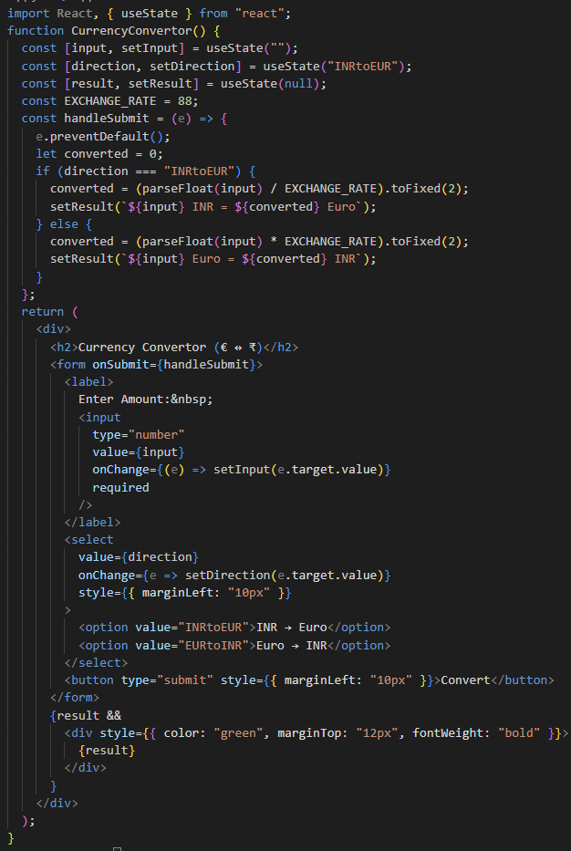App Component (App.js)

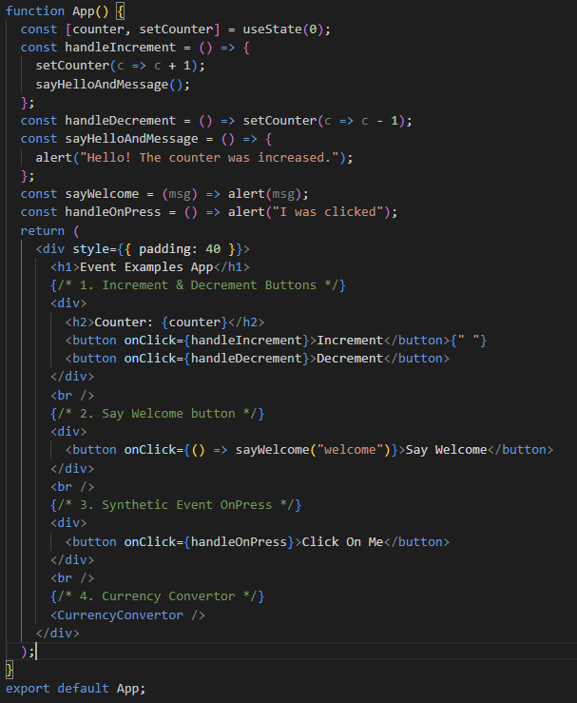

1. Quick CSS (App.css)

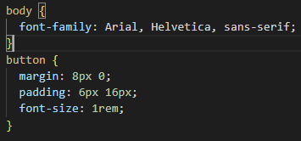

1. 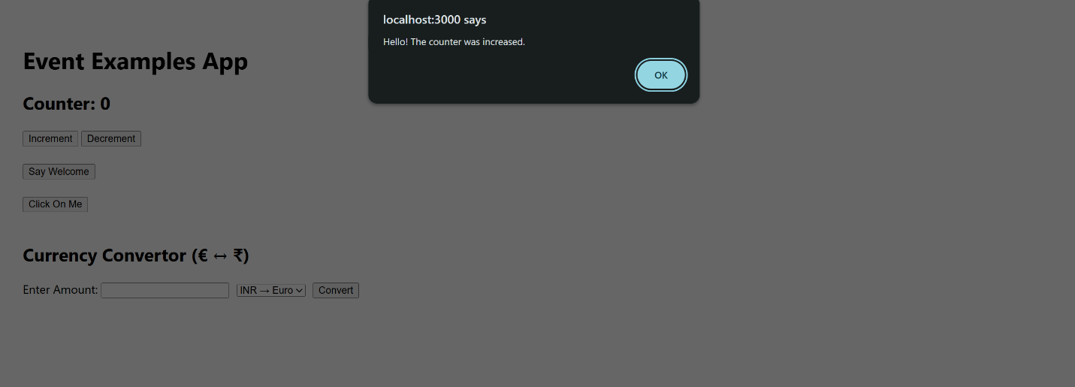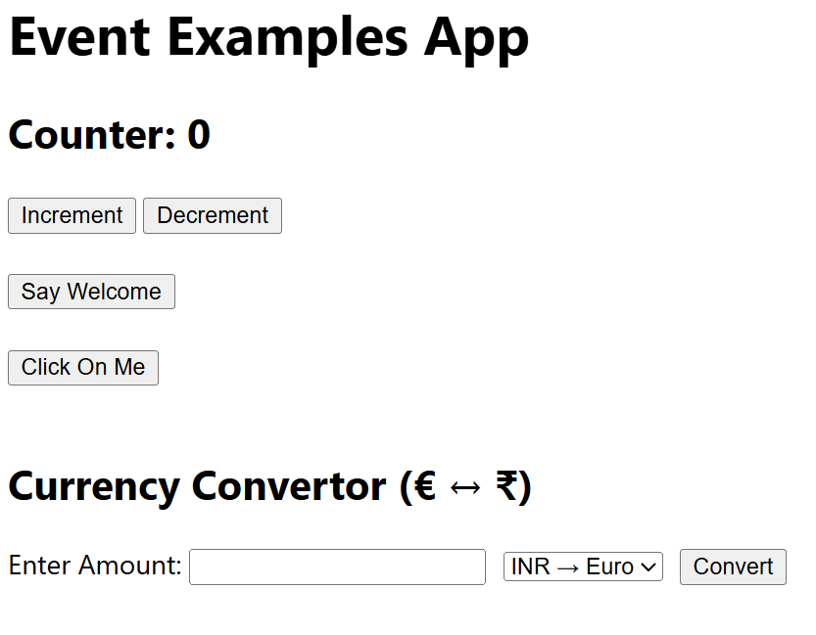Run The App

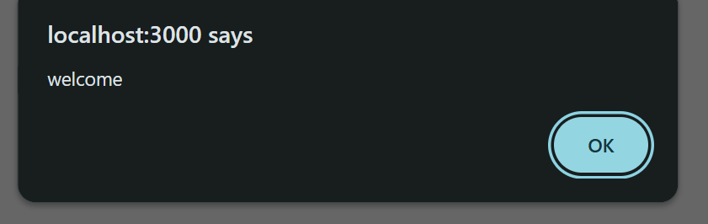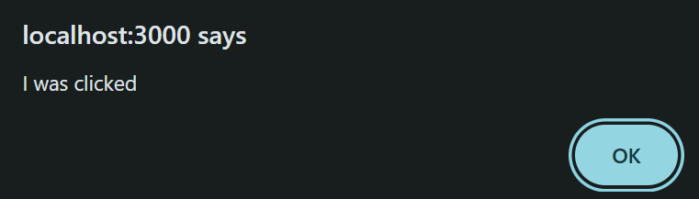when clicked on “Say Welcome” When Clicked on “Click on me”

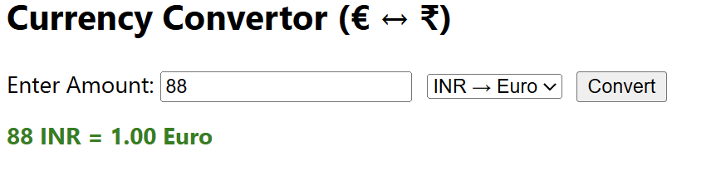

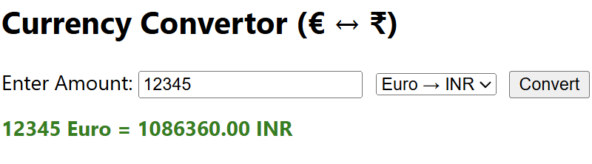

**12. ReactJS-HOL (MANDATORY)**

Create a React Application named “ticketbookingapp” where the guest user can browse the page where the flight details are displayed whereas the logged in user only can book tickets.

The Login and Logout buttons should accordingly display different pages. Once the user is logged in the User page should be displayed. When the user clicks on Logout, the Guest page should be displayed.

STEPS:

* Set Up the Project
* App Structure
* We’ll need:
  + App: Manages authentication state.
  + LoginButton and LogoutButton
  + FlightList: Always visible (for guest and user)
  + GuestPage: Shown when not logged in; allows browsing only.
  + UserPage: Shown when logged in; allows booking.
* 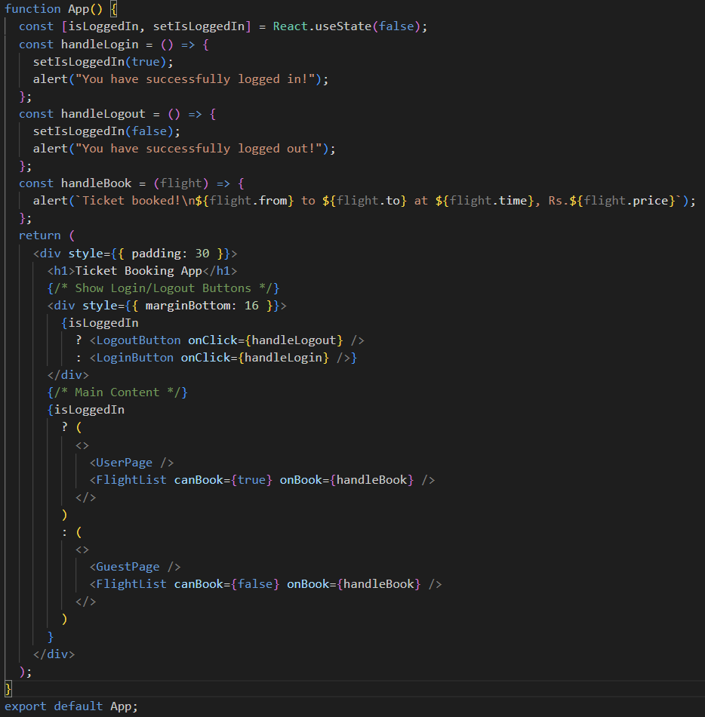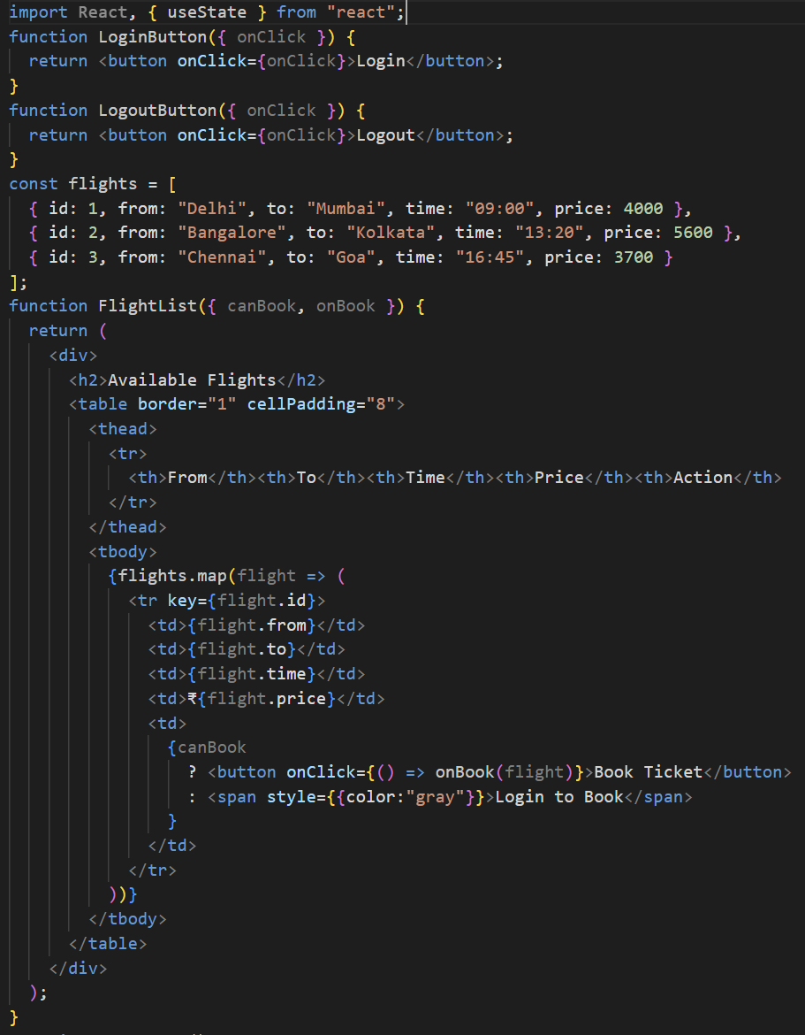src/App.js
* Basic Styling: src/App.css

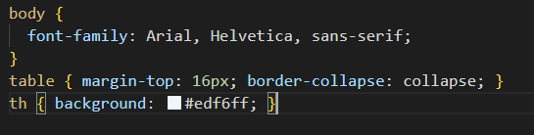

* 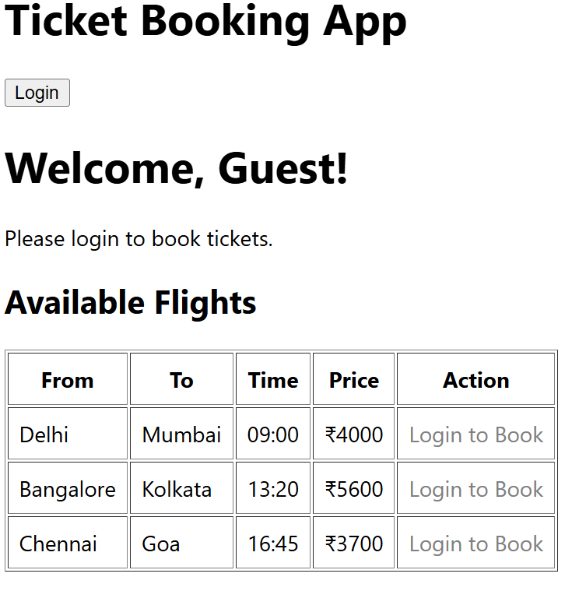Start App

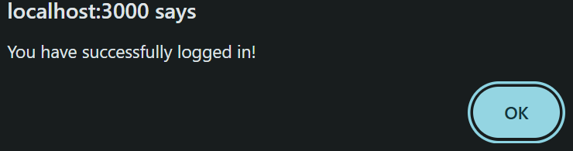

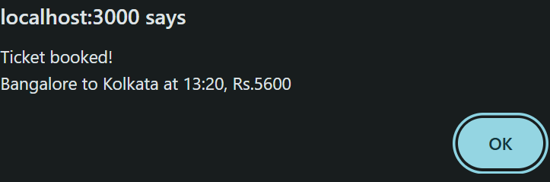

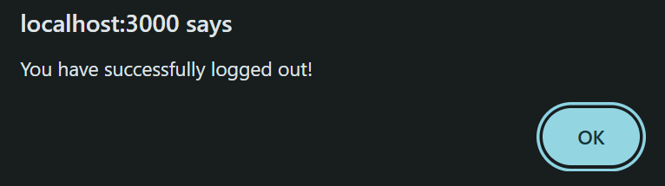

**13. ReactJS-HOL (MANDATORY)**

Create a React App named “bloggerapp” in with 3 components.

1. Book Details
2. Blog Details
3. Course Details

Implement this with as many ways possible of Conditional Rendering.

STEPS:

1. Create the React App



1. Clean Up the Boilerplate

Inside the src folder:

* + - Delete: App.test.js, logo.svg, reportWebVitals.js, setupTests.js
    - Clean up App.css and App.js for a fresh start.

1. BookDetails.js

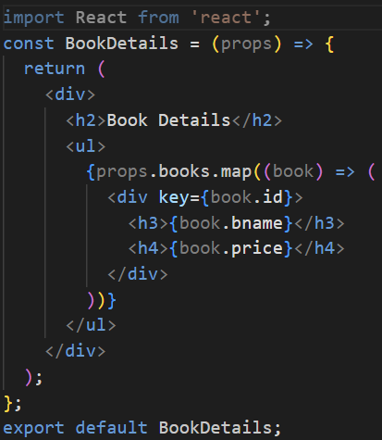

1. BlogDetails.js

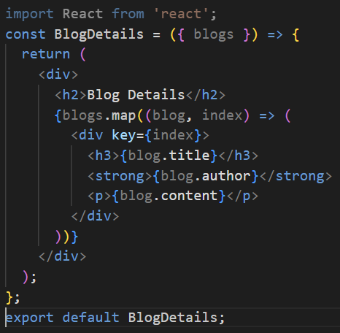

1. CourseDetails.js

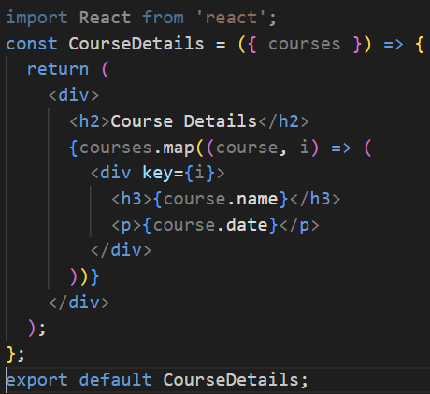

1. App.js
   * We will now implement 3 types of conditional rendering:
     + Short-circuit evaluation (&&)
     + Ternary operator (? :)
     + 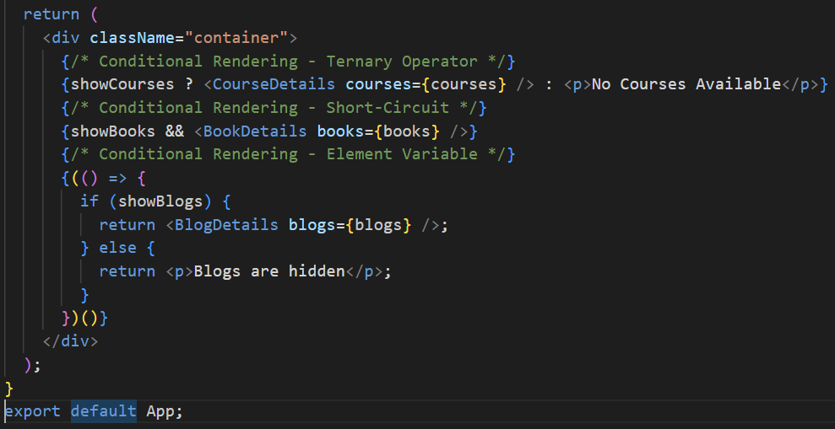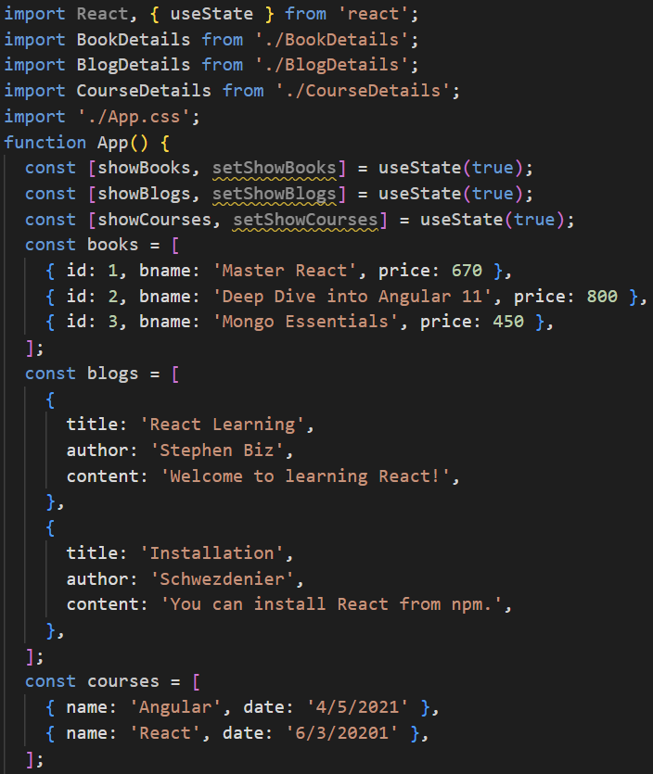Element variables
2. App.css

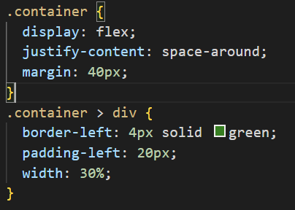

1. run the app:

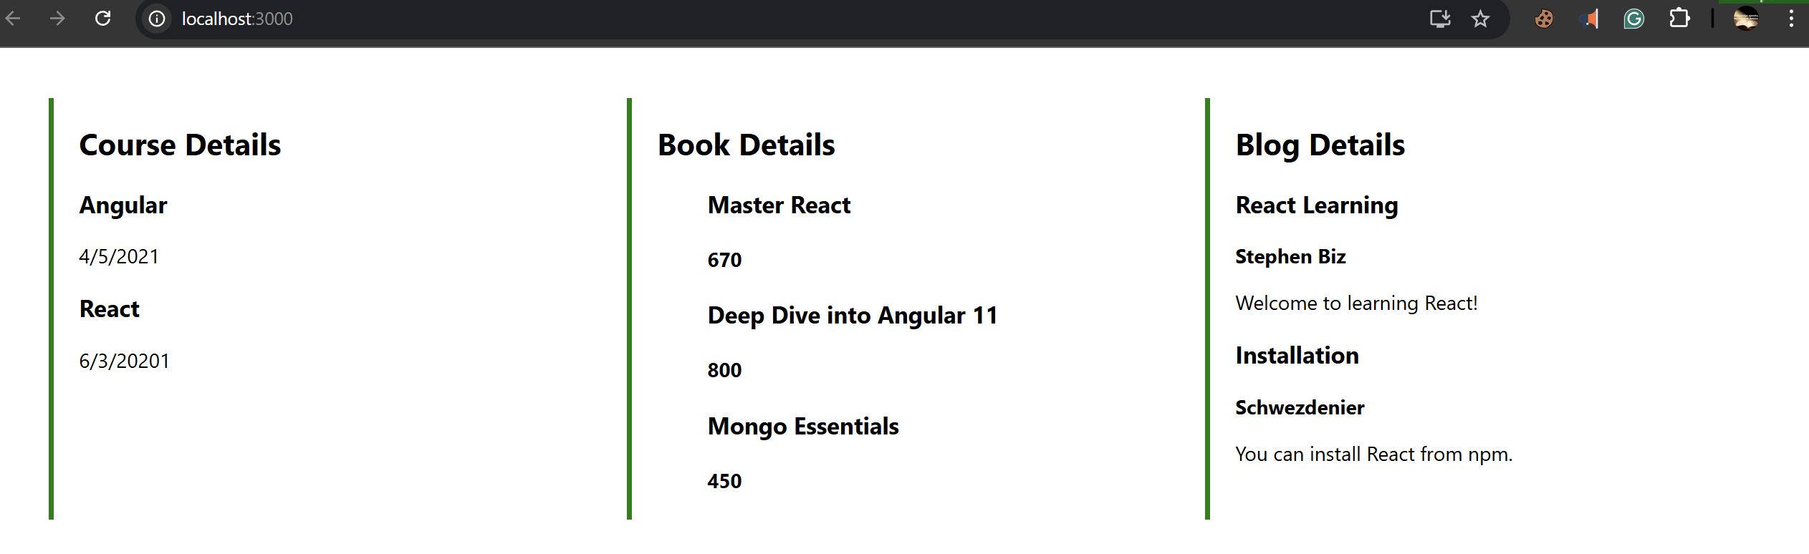

**15. ReactJS-HOL (NON - MANDATORY)**

Create a React App named “ticketraisingapp” which will help to raise a complaint and get it resolved.

Create a component named “ComplaintRegister” with a form containing a textbox to enter the employee name and a textarea to enter the complaint. Use “handleSubmit” event of the button to submit the complaint and generate a Reference number for further follow ups in the alert box.

Create React App



Create the “ComplaintRegister” Component

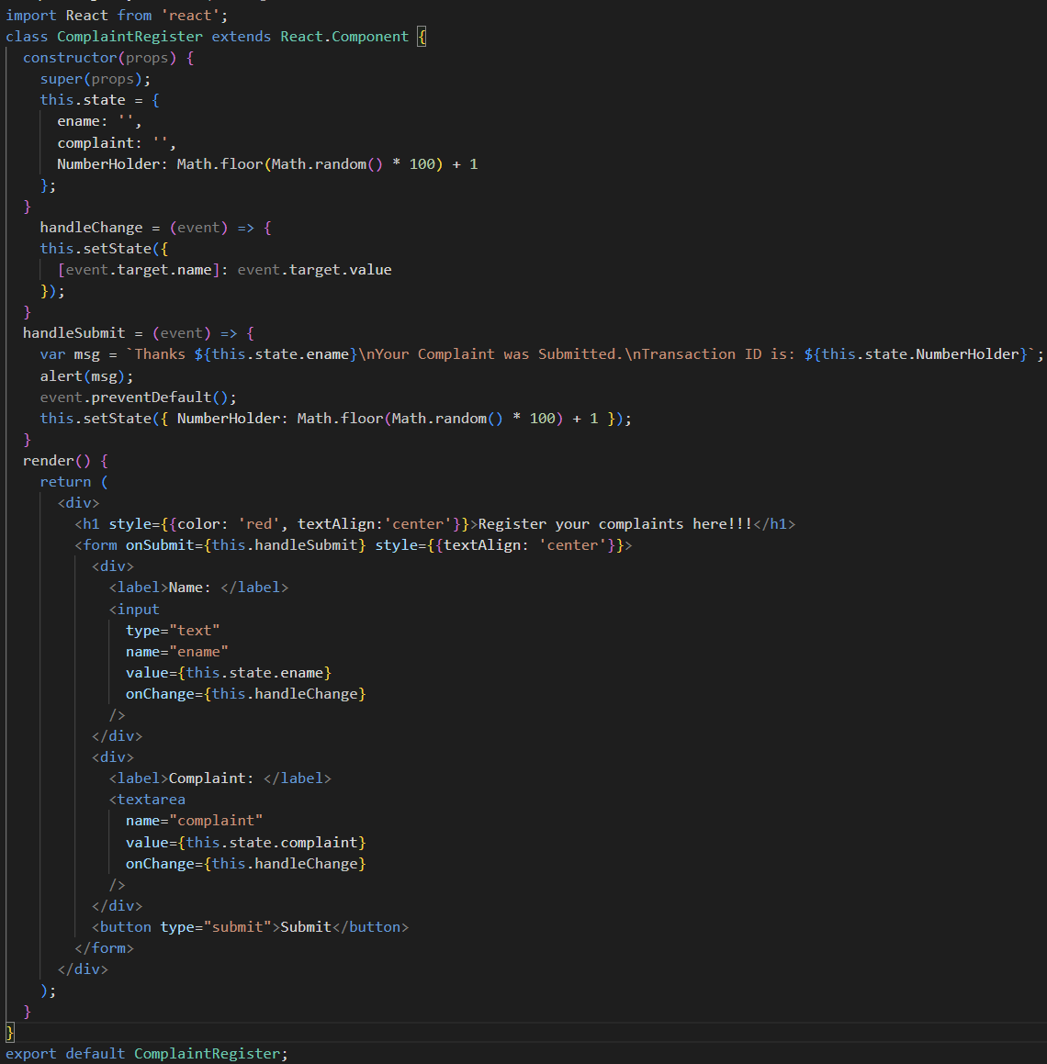

Use the Component in App.js

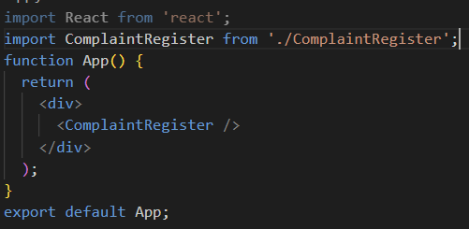

Start the App

